Name: ________________________________________________________________ |  | Date: ___________________
 | Year 8 Mathematics  Volume Mini Test | __________  20  = _________ %
CALCULATOR ALLOWED

AREA
Triangle |  |  |  | A = ½ × Base × Ht | Parallelogram |  |  |  |  | A = Base × Ht
Square |  |  |  | A = l × l | Trapezium |  |  |  | A = ½ × (a + b) × Ht
Rectangle |  |  |  | A = l × w | Circle |  |  | A = π × r × r  or  A = π × r²
VOLUME |  |  |  |  | CONVERTING UNITS OF VOLUME
Any Prism |  |  | V = Area of base x height |  | 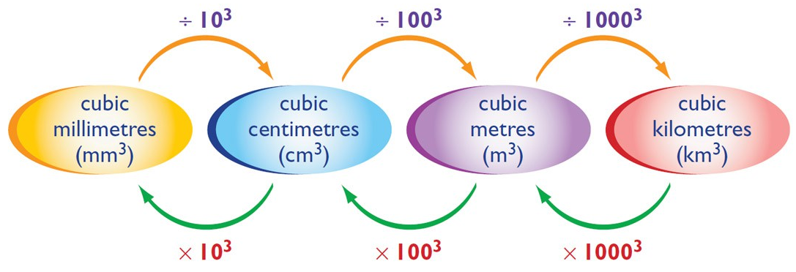

1. [4 marks: 1, 1, 1, 1]
Convert the following units of volume:

a) 2 cm³ = _______________________ mm³ b) 65 000 cm³ = _______________________ m³

b) 1.87 km³ = _______________________ m³ d) 4 500 000 mm³ = _______________________ m³

2. [2 marks: 1, 1]
Determine the volume of each of the following shapes (in cubic units) by counting cubes. Each cube is one cubic centimetre.

a) | b)
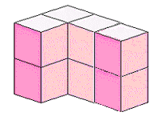  Volume:_________ | 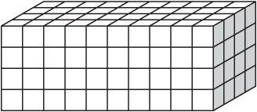  Volume:_________
3. [10 marks: 2, 2, 2, 2, 2]
Determine the volume of the following shapes:

a) | 9.5 cm  Area of base = 15.6cm² | b) | 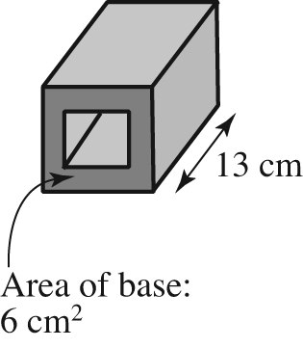
c) | 5 cm  8 cm  2 cm | d) | 4 cm  4 cm  5 cm
e) | 3 m  4 m

4. [4 marks: 3, 1]
a) How many boxes that measure 20 cm × 25 cm × 50 cm can you fit in a box that is
1 m × 1 m × 1 m?

b) What is the capacity (in litres) of each smaller box? Remember that 1 cm³ = 1 mL

